Profile Setup for Blitz ‘Report Access’:

Step 1:

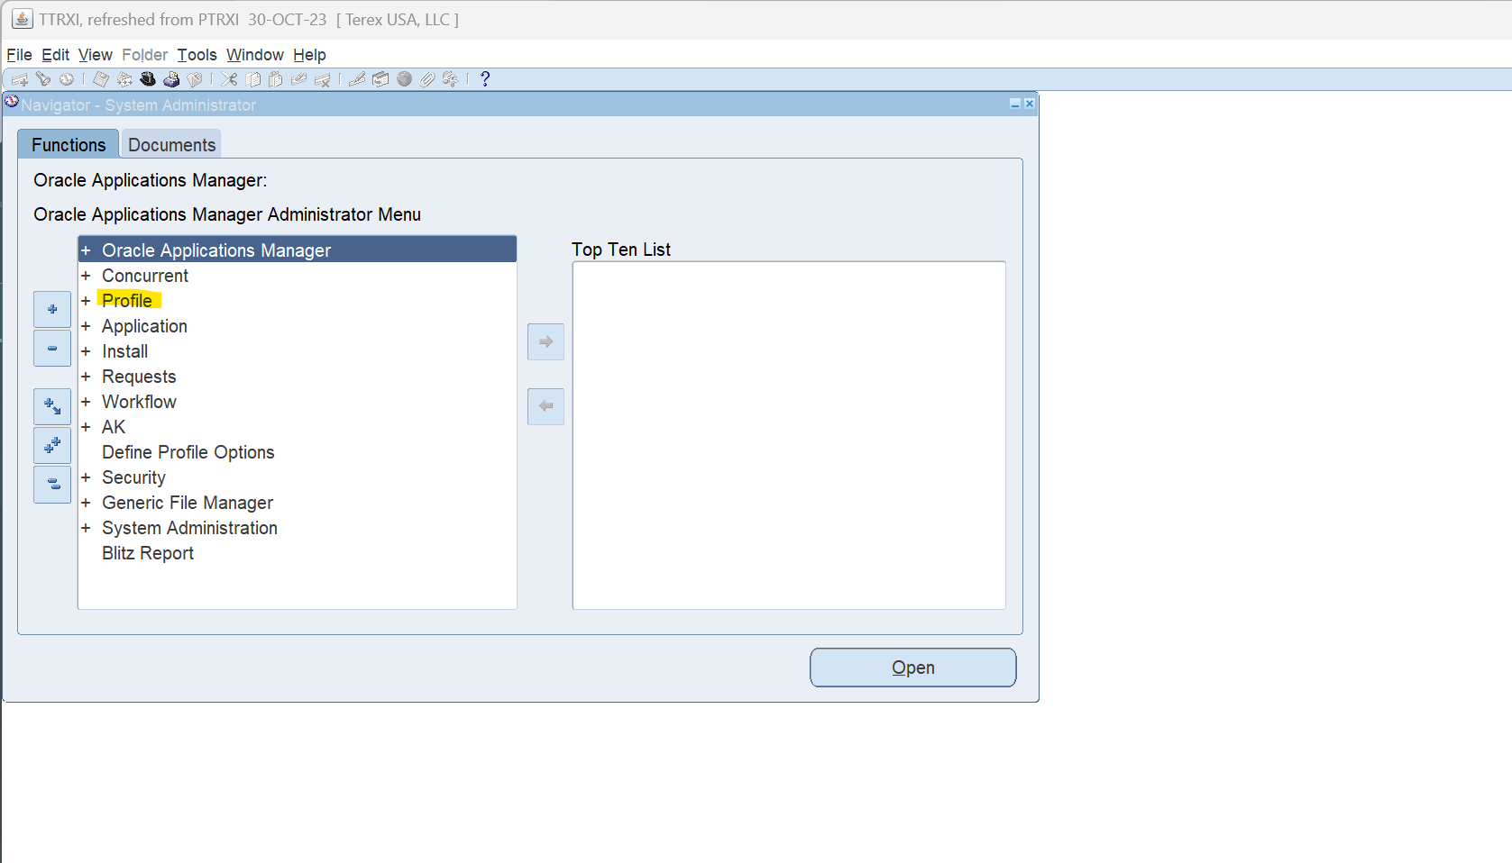

Step 2:

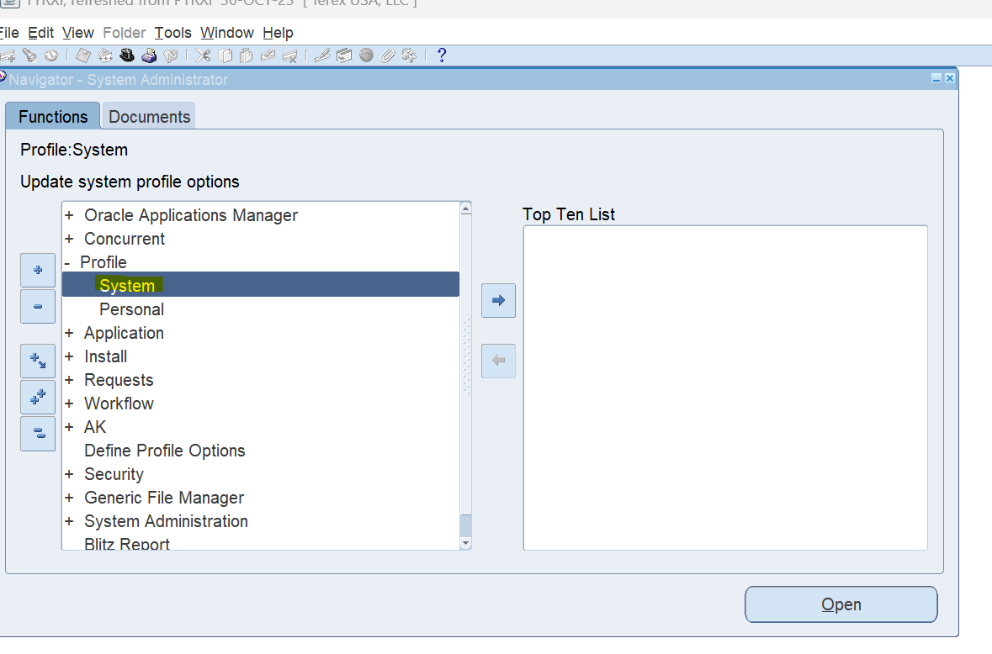

Step 3

Do for each of the user separately.

Username:

- SUPRIYA.NAINGLAJ - developer
- SHASVANTH.SHANMUGAM - developer
- SANGEETHA.MATHIVANAN – User admin
- GOMATHIPRIYA.GANESAN – User admin
- MUGDHA.JOSHI – User admin

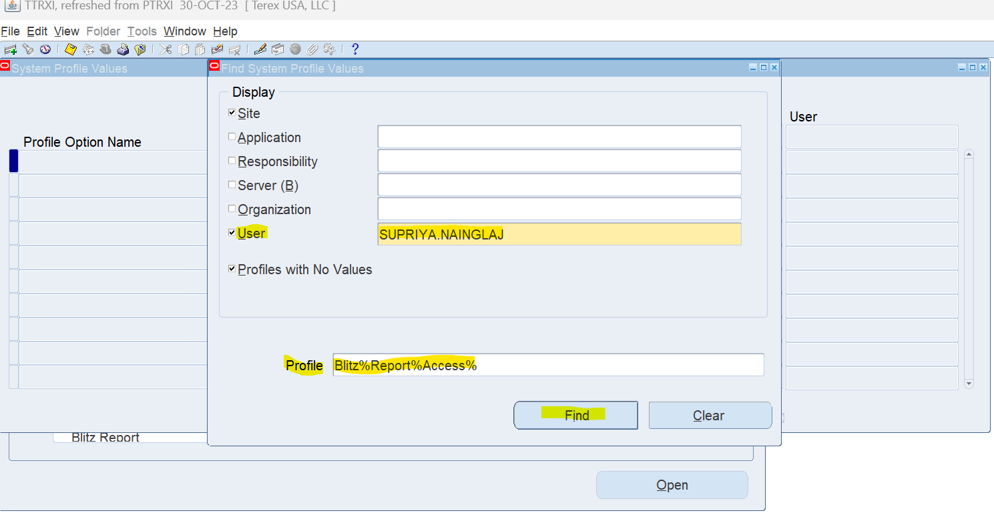

Step 4

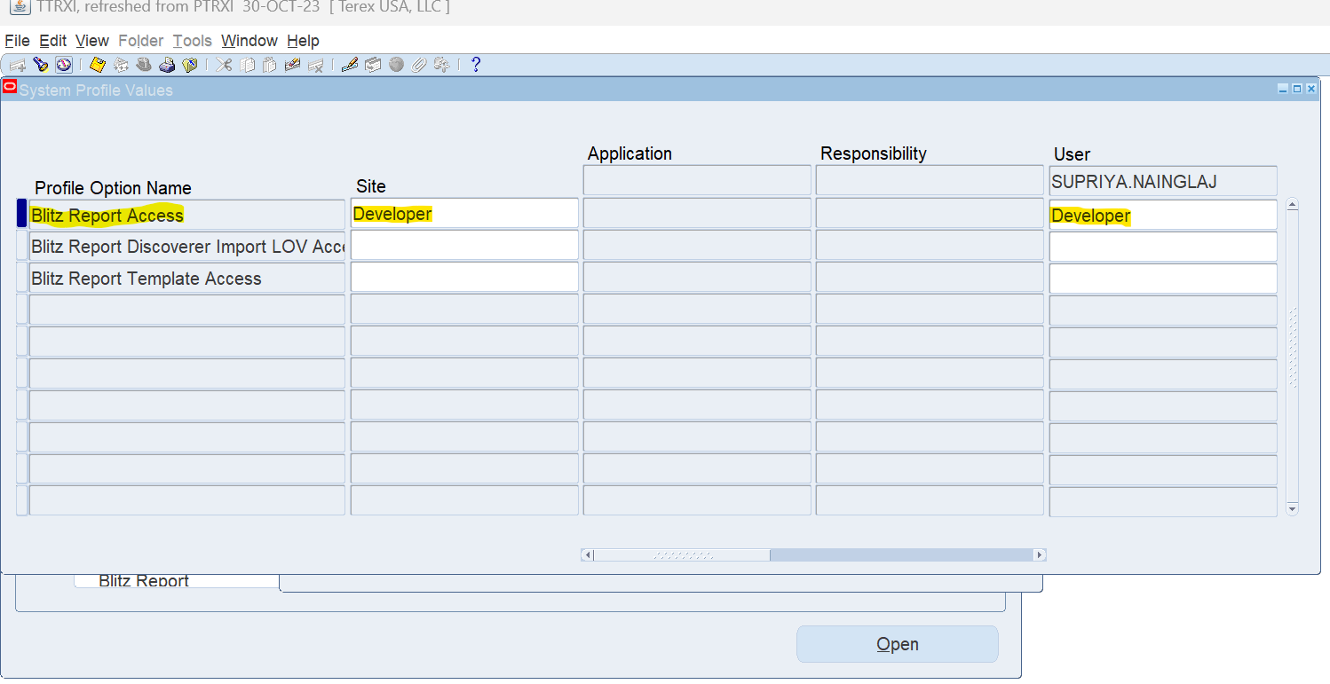

Step 5: Save.

